

Object-Oriented Programming

Final Project User Manual

**Snake Game**

*Using Java Swing*

Furqan Ul Haq – 2412189

Syed Mujtaba Mehdi – 2412219

Syed Mohammed Burair Zaidi – 2412218

***Introduction***:

The Project aims to develop a classic Snake Game with the use of Java Swing where player can control the snake to eat apples. The project is a GUI based project which will make it user friendly and interactive for users. The game allows the developer to show case their skills with the use of OOPs concepts in Java.

***Process***:

***Main Menu***

The first window user interacts with after launching the Program is the Main Menu window in which pops up and the user can choose between two options:

* Choose New Game to start the Snake Game
* Choose Exit button to exit the game

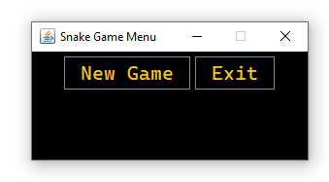

***New Game***

If the user clicks the *New Game*button, a new window will appear at the centre of Screen and Main Menu window will be disposed. The New window will start the Game and user can see a black background interface having Green Colored Snake and Red Apples spawning at random spots inside the frame.

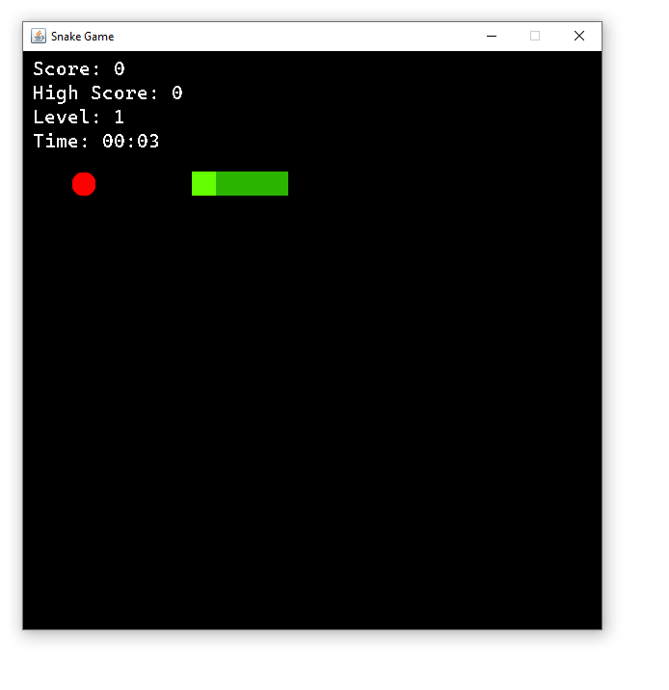

At the very Top-Left of the frame is the Score board, High Score, Difficulty Level and Timer.

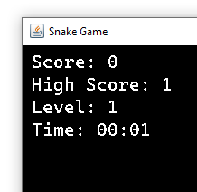

Every time the snake eats an apple, the value of Score will be increased by 1 as well as 1 unit will be added to the body of snake from will tail making the Snake longer and harder for user to play, while the timer will keep running until the game is over.

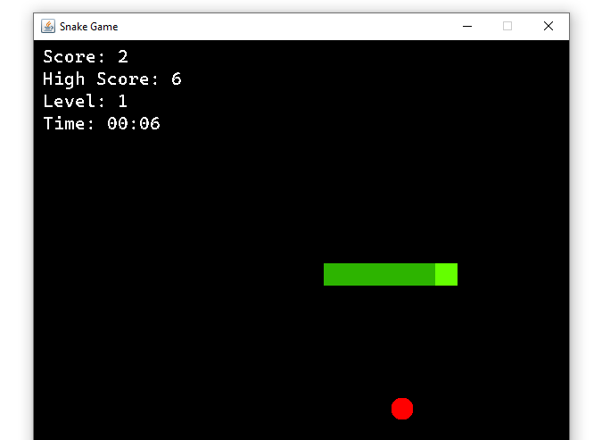

After eating every 5 Apples, The difficulty level will be increased by 1 and the speed of Snake will be increased by 25% of its previous speed.

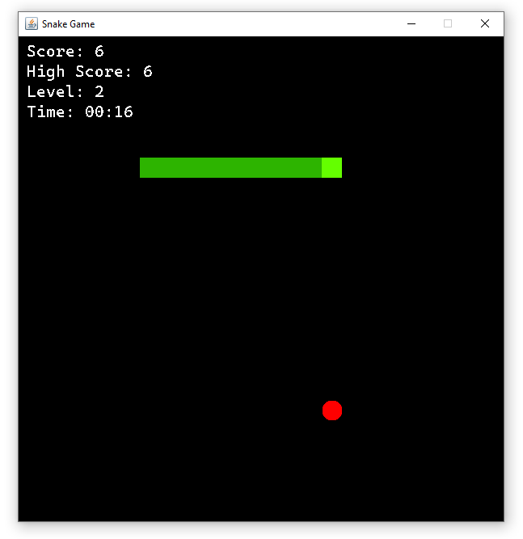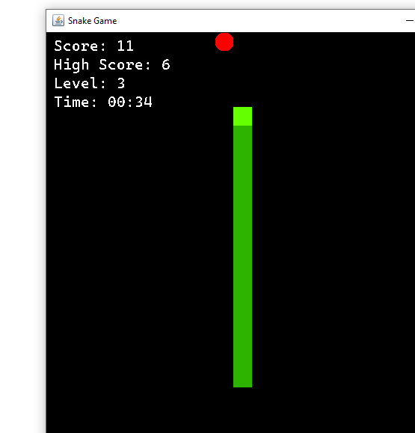

If the current score surpasses the High Score, the value of High Score will be replaced with value of Current score.

***Game Over***

If the Snake collides with the wall or its own body, the Snake will die and the Game will be over and a Dialogue Box will appear having title “*Game Over*” and it will ask user if they want to Restart the game or Exit the Program

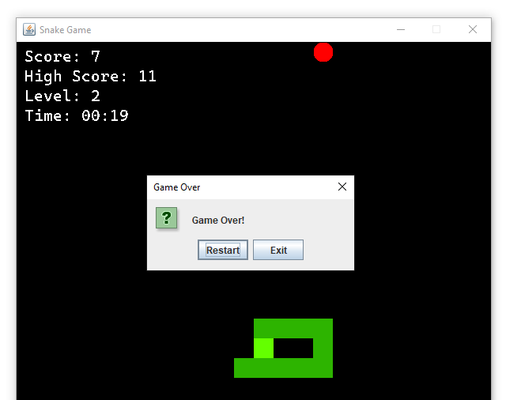

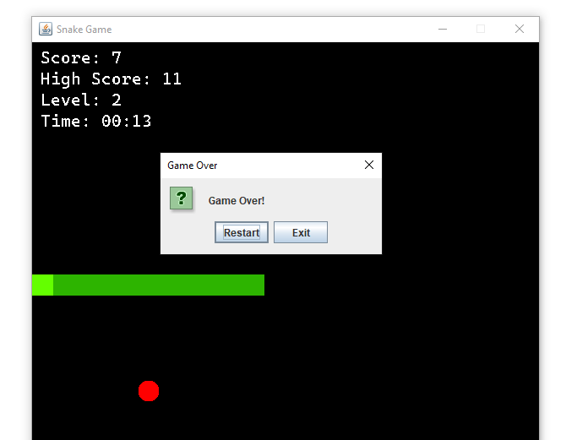

Clicking Restart button will Start the game again with initial values of Score Level and Timer while clicking the Exit button will lead to Exiting the Program and the Game window will be disposed and the results will be saved in a Text file at the given path in String format